**Azure DevOps Sample Logic Apps Release Pipeline Screenshots**

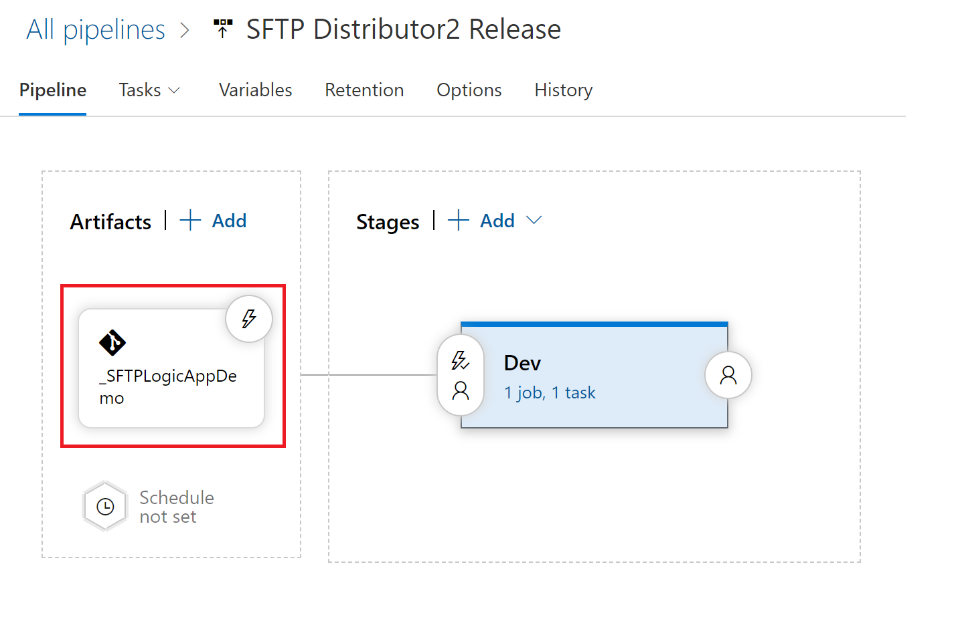

Figure - Select the Repo containing your ARM template files

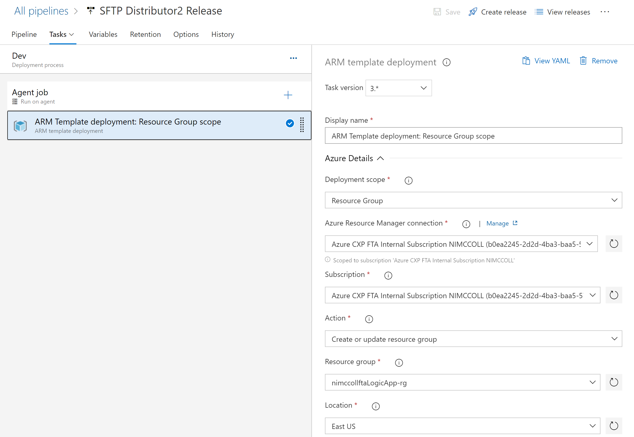

Figure - Add an ARM Template deployment task to your pipeline

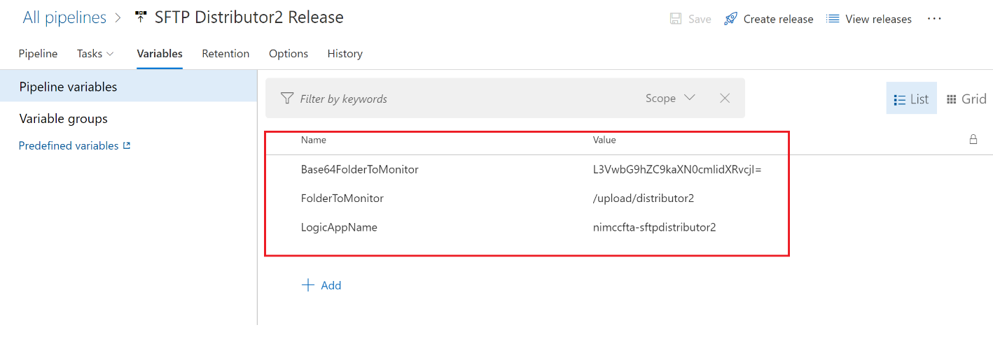

Figure - Create pipeline variables for the values you need to override in the ARM template

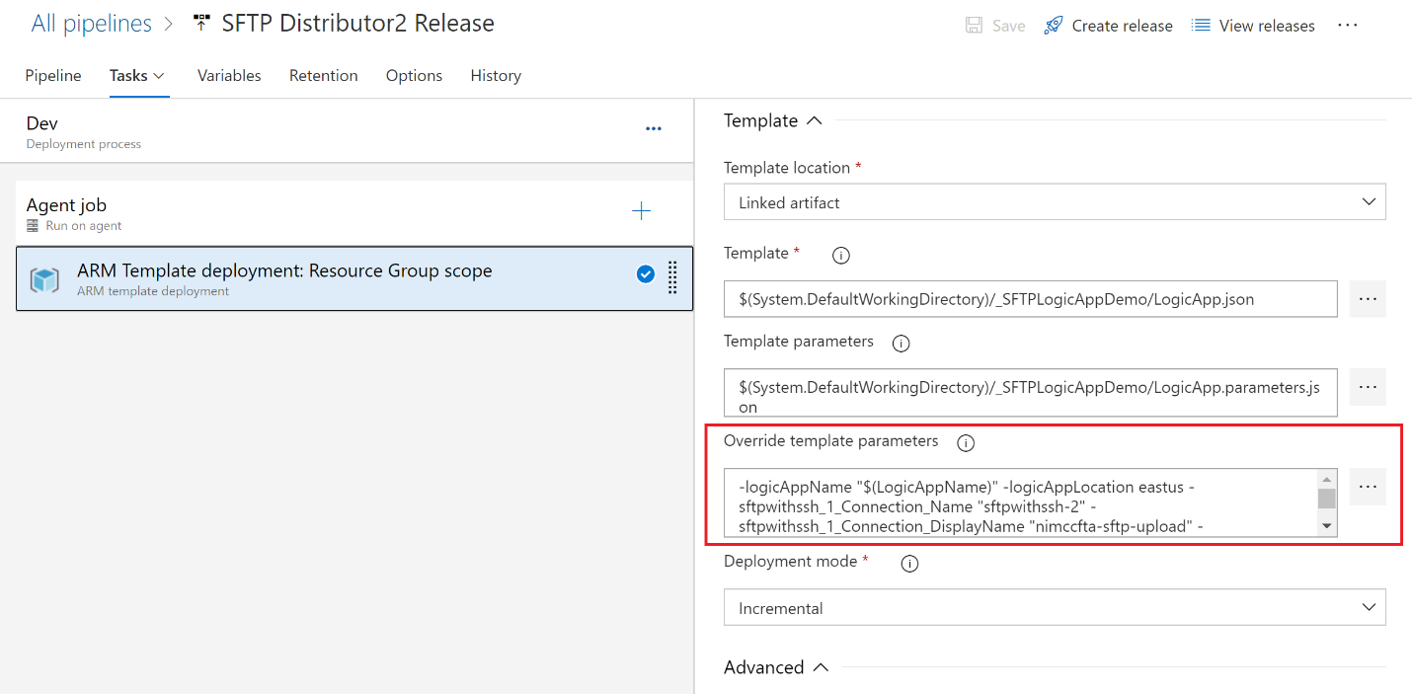

Figure - Override template parameters with your pipeline variables